Federated Deep Reinforcement Learning for
Privacy-Preserving Coordination of Provincial-Scale
Battery Energy Storage Systems in High-Wind
Grids
Mahmoud Mohammadnezhad Kiasari; Hamed H. Aly, SMIEEE
Smart Grid and Green Power Research Laboratory
Electrical and Computer Engineering Department, Dalhousie University

Abstract— Battery energy storage systems (BESS) are crucial for wind curtailment management. This is hindered by regulatory limitations on competition among utilities that prohibit shared operational data in a central governance system. This proposal presents a federated deep reinforcement learning that coordinates three geographically distributed BESS aggregates with a total capacity of 320 MWh. The utilization of this method could eliminate the requirement for centralized data aggregation on a provincial scale. The proposed Hybrid Q-Informed Soft Actor-Critic with Federated Learning Averaging (HQI-SAC-Fed) attempts to optimize multiple objective rewards in cooperation with differential privacy (ε=1.0). Upon the Nova Scotia 2030 ambitious plan of 2,100 MW of renewable energy resources (RES), this method reaches approximately 97% of the functionality delivered by a completely centralized approach. Meanwhile, HQI-SAC-Fed minimizes the curtailment by 23 to 24%. The methodology produces a net present value of US $27.3 million, with privacy mechanisms that are resilient to gradient inversion attacks.
Index Terms--Federated Learning, reinforcement Learning, Battery Energy Storage, Wind Integration, Privacy Preservation, Multi-objective Optimization

Introduction
The worldwide shift to renewable energy has elevated the status of battery energy storage systems (BESS) to that of critical infrastructure, contributing to the development of a more stable and economically efficient grid. As offshore wind capacity scales up to the gigawatt range, the intermittency issue becomes more acute; this generation loss due to wind curtailment could account for 15-20% of annual generation in the absence of proper storage and coordination mechanisms. Provincial and regional grid planners considering multi-site BESS deployments face a fundamental need to manage multi-sited BESS deployments: coordinated operation creates the greatest benefits at the system level, but centralized control requires that commercially sensitive operational information be released across competing utilities and municipalities. Nova Scotia's ambitious renewable energy goal in 2030 is a good example of this dilemma. The province plans to integrate 2,100 MW of offshore wind, spread across Guysborough, Halifax, and Cape Breton, and phase out coal-fired generation. Grid operator studies suggest that 320-520 MWh capacity of distributed BESS is needed to maintain reliability at a level ensuring 80% renewable penetration. In Nova Scotia, grid operations involve investor-owned utilities, municipal utilities, and privately operated microgrids governed under different regulatory frameworks. These structural differences create jurisdictional barriers to sharing operational data, even though coordinated BESS dispatching would provide clear system-level benefits.
Standard optimization methods are inadequate for these constraints. Model Predictive Control (MPC) requires centralized forecasting and state estimation, which are incompatible with distributed ownership; market-based coordination through price signals alone creates suboptimal equilibria when agents do not see system-wide constraints. Existing methods for BESS control based on deep reinforcement learning (DRL) are usually devoted to single-site optimization, which ignores the coordination benefits that have the potential to save millions of dollars per year.
Federated learning (FL) provides a paradigm shift in privacy-preserving multiagent optimization. Rather than having all the raw data in an aggregated fashion, in FL, all learning is orchestrated by averaging the model parameters. Recent studies on smart grid applications have used FL for load forecasting and voltage control; however, none of the previous studies have covered provincial-scale BESS coordination with strict privacy guarantees and multi-objective control.
The following contributions are made in this paper:
- Federated reinforcement learning architecture: To the best of the authors knowledge, this is the first application of federated deep RL to multi-site BESS coordination on a provincial scale (three sites, 320 MWh total), which enables privacy-preserving optimization between competing utilities.
- Hybrid Q-Informed SAC (HQI-SAC): By coupling Q-value guidance into Soft actor critic, this approach enables sample-efficient multi-objective learning (energy arbitrage, curtailment reduction, frequency regulation, & carbon mitigation).
- Admittance-weighted graph embedding: A physics-informed state representation is developed using an admittance matrix, which increases the generalization capability with respect to topology changes (e.g., the addition of new wind farms).
- Differential privacy: An empirical analysis provides a privacy guarantee with epsilon = 1.0 through gradient noise injection, supported by an empirical evaluation of differential privacy using its gradient inversion attack.
- Economic validation: A detailed analysis of Nova Scotia towards 2030 shows a net present value of US$27.3 million, along with a reduction of 23.7 percent of curtailments and the unloading of 162,000 tCO2, proving the economic viability of the proposed framework.
Experiments on a scaled model of the Nova Scotia topology, with 2,100 MW of WWS, 580 MW of solar, and 1,700 MW of peak load, of the size of the unit under consideration, demonstrated that the federated approach achieved 96.8% of centralized performance, exhibiting resilience to gradient inversion attacks that were tested. Ablation studies support the importance of graph embedding and federated coordination, providing 8.3 and 12.1 containment of performance, respectively.
Federated reinforcement learning is adopted because centralized DRL violates data-sharing constraints, independent DRL incurs significant coordination losses (≈32%), and price-only signals provide incomplete observability under curtailment conditions

related work
  - Battery Storage Optimization
Energy arbitrage using storage has been studied in detail using MPC and MI. These techniques assume perfect forecasting, which is an unrealistic presumption regarding wind generation, as there is normally a 15-25% RMSE. The latest DRL (DQN, A3C, and PPO) methods are successful under uncertainty but are only applicable to single-site optimizations. Multi-agent RL for coordinated storage is present in the microgrid literature, but has the drawback that it assumes centralized training, rendering it incompatible with privacy requirements[1], [2].

  - Federated learning in Power Systems
As part of power systems, FL can be applied in load forecasting for utilities without the exchange of customer information, distributed state estimation, and voltage control in the distribution networks. The number of these applications uses supervised learning (forecasting) or single-task RL methods. To the best of our knowledge, the results of this study are the first to address multi-objective RL for storage coordination with explicit privacy guarantees. The HQI-SAC-Fed framework proposed in this study addresses this research gap.

  - Power Systems using Graph Neural Networks

Graph neural networks take advantage of grid topology to provide more accurate predictions[3], [4]. Applications range from cascading failure analysis and optimal power flow approximation to state estimation. This study uses graph convolutions to generate admittance-weighted representations of states, which enable the BESS agents to gather spatial correlations in wind generation and load patterns.

Problem formulation
  - System Model
Consider a provincial grid with $N_{B}=3$geographically distributed BESS installations indexed by $b∈\{1,2,3\}$(Guysborough, Halifax, Cape Breton). Each BESS has:
- Capacity $E_{b}^{max}$: (200, 120, 200) MWh
- Power rating $P_{b}^{max}$: (100, 60, 100) MW
- Efficiency $η_{b}$: 92% (round-trip)
- Current state of charge ${\text{SOC}}_{b}(t)∈[0.1,0.9]$(10–90% operational range)
The grid includes $N_{w}=3$offshore wind farms with stochastic generation $P_{w}(t)$, total capacity 2,100 MW. System-wide load demand $P_{L}(t)$follows diurnal patterns with peak 1,700 MW. Excessive wind generation leads to curtailment.
 | $$P_{\text{curtail}}(t)=max⁡(0,\sum_{w=1}^{N_{w}}{P_{w}\left(t\right)-P_{L}\left(t\right)-P_{trans}^{max}-\sum_{b=1}^{N_{B}}{P_{b}^{charge}(t)}}$$ | (1)

  - Multi-Objective Optimization

Each BESS agent controls charge/discharge power $P_{b}(t)∈[-P_{b}^{max},P_{b}^{max}]$to maximize a multi-objective reward:
 | $$r_{b}(t)=w_{1}⋅r_{\text{arbitrage}}(t)-w_{2}⋅r_{\text{curtail}}(t)-w_{3}⋅r_{\text{freq}}(t)-w_{4}⋅r_{\text{penalty}}(t)$$ | (2)

- $r_{\text{arbitrage}}=P_{b}(t)⋅Δλ(t)$: profit from price arbitrage
- $r_{\text{curtail}}=P_{\text{curtail}}(t)$: penalty for wasted wind
- $r_{\text{freq}}=∣Δf∣$: frequency regulation bonus
- $r_{\text{penalty}}=max⁡(0,∣{\text{SOC}}_{b}(t)-0.5∣)$: SOC deviation penalty
Weights $w=[0.4,0.3,0.15,0.1,0.05]$balance objectives based on stakeholder priorities. The reward weights were selected via validation-year tuning and exhibited stable performance under ±20% perturbation.

  - Federated Multi-Agent RL Formulation

Standard multi-agent RL requires central coordination and full observability of the environment. The federated formulation decentralizes the components as follows
Local MDP per BESS: $M_{b}=(S_{b},A_{b},P_{b},r_{b},γ)$
- State $s_{b}(t)∈R^{d}$: local bus voltage/frequency, SOC, local wind forecast, electricity price, graph-embedded neighbors’ generation
- Action $a_{b}(t)∈R$: $P_{b}^{\text{charge/discharge}}(t)$
- Transition $P_{b}$: SOC dynamics + grid power flow
Federated Coordination: Agents collaboratively train policies $π_{b}(s_{b};θ_{b})$via periodic synchronization parameters $θ_{b}$via FedAvg[3], [4], [5]:
 | $$θ_{\text{global}}^{\left(k + 1\right)}=\sum_{b=1}^{N_{B}}{\frac{E_{b}}{E_{\text{tot}}}}θ_{b}^{\left(k\right)}$$ | (3)
Each BESS updates locally for $K=50$gradient steps, then uploads $θ_{b}$to aggregator. Privacy is preserved as raw measurements $\left(s_{b}(t),r_{b}(t)\right)$never leave local site.

  - Differential Privacy via Gradient Perturbation

To prevent parameter inversion attacks, we added calibrated Gaussian noise:
 | $${\tilde{θ}}_{b}=θ_{b}+N(0,σ^{2}I),σ=\frac{C\sqrt{2ln⁡(1.25/δ)}}{ε}$$ | (4)

where $C$is the gradient clipping bound, $ε=1.0$is the privacy budget, and $δ={10}^{-5}$is the failure probability. This mechanism provides $\left(ε , δ\right)$- differential privacy under composition[6], [7]. At the provincial scale with three BESS sites, $ε=1.0$represents an acceptable privacy–utility trade-off under current Canadian utility regulations, offering strong protection (reconstruction MSE $>0.85$) while retaining 97% of economic performance. Federation over 100 communication rounds accumulates to an effective privacy budget of $ε_{\text{total}}≈10$under basic composition; tighter bounds using RDP or zCDP are left for future work.

Proposed his-sac-fed methodlogy
  - Admittance-Weighted Graph Embedding
Standard RL state vectors ignore grid topology. We embed spatial correlations via graph convolution on admittance matrix $Y ADDIN ZOTERO_ITEM CSL_CITATION \{"citationID":"fGQmnG1E","properties":\{"formattedCitation":"[8]","plainCitation":"[8]","noteIndex":0\},"citationItems":[\{"id":1891,"uris":["http://zotero.org/users/9870935/items/NGJXHP59"],"itemData":\{"id":1891,"type":"article","abstract":"We present a scalable approach for semi-supervised learning on graph-structured data that is based on an efficient variant of convolutional neural networks which operate directly on graphs. We motivate the choice of our convolutional architecture via a localized first-order approximation of spectral graph convolutions. Our model scales linearly in the number of graph edges and learns hidden layer representations that encode both local graph structure and features of nodes. In a number of experiments on citation networks and on a knowledge graph dataset we demonstrate that our approach outperforms related methods by a significant margin.","DOI":"10.48550/ARXIV.1609.02907","license":"arXiv.org perpetual, non-exclusive license","note":"version: 4","publisher":"arXiv","source":"DOI.org (Datacite)","title":"Semi-Supervised Classification with Graph Convolutional Networks","URL":"https://arxiv.org/abs/1609.02907","author":[\{"family":"Kipf","given":"Thomas N."\},\{"family":"Welling","given":"Max"\}],"accessed":\{"date-parts":[["2025",12,27]]\},"issued":\{"date-parts":[["2016"]]\}\}\}],"schema":"https://github.com/citation-style-language/schema/raw/master/csl-citation.json"\} [8]$:
 | $$h_{i}^{\left(l + 1\right)}=σ\left(\sum_{j∈N(i)}{{\tilde{Y}}_{ij}}h_{j}^{\left(l\right)}W^{\left(l\right)}\right)$$ | (5)
where ${\tilde{Y}}_{ij}=∣Y_{ij}∣/∥Y∥_{1}$is normalized admittance, $h_{b}^{\left(0\right)}=[{\text{SOC}}_{b},P_{w,b},λ_{b}]$ are raw features. This 2-layer GCN produces graph-aware state $s_{b}^{g}∈R^{d}$.

  - Hybrid Q-Informed Soft Actor-Critic

The standard SAC maximizes the entropy-regularized return[9], [10], [11]:
 | $$J(π)=E_{τ∼π}\left[\sum_{t}{\left(r(t)+αH(π(⋅∣s_{t}))\right)}\right]$$ | (6)
with augmented Q-value guidance to accelerate learning:
 | $$π(a∣s)=arg⁡\underset{a}{max⁡}\left(Q(s,a)+αH(π(⋅∣s))-β\text{ KL}[π(⋅∣s)∥π_{Q}]\right)$$ | (7)

where $π_{Q}(a∣s)∝exp⁡(Q(s,a)/α)$is Q-derived policy,
$β$is Q-guidance weight.
Actor network: $π_{θ}(a∣s)$parameterized as Gaussian with
$tanh⁡$squashing.
Critic networks: Twin Q-functions $Q_{ϕ_{1}},Q_{ϕ_{2}}$(clipped
Double Q-learning).
Training: Each BESS samples local replay buffer $D_{b}$and updates:
 | $$L_{Q}(ϕ_{i})=E_{(s,a,r,s^{'})∼D_{b}}\left[{\left(Q_{ϕ_{i}}(s,a)-y\right)}^{2}\right]$$ | (8)
 | $$y=r+γ\left(\underset{i}{min⁡}Q_{ϕ_{i}^{-}}(s^{'},a^{'})-αlog⁡π_{θ}(a^{'}∣s^{'})\right)$$ | (9)

  - Federated Aggregation Protocol

- Initialize global policy $θ^{\left(0\right)}$; distribute to all BESS
- For federation round $k=1,…,K$:
- Each BESS trains locally for $K=50$episodes
- Upload noisy parameters ${\tilde{θ}}_{b}^{\left(k\right)}=θ_{b}^{\left(k\right)}+N\left(0,σ^{2}I\right)$
- Aggregate (capacity-weighted)
$$θ^{\left(k\right)}=\sum_{b}{\frac{E_{b}}{E_{\text{tot}}}}{\tilde{θ}}_{b}^{\left(k\right)}$$
- Broadcast $θ^{\left(k\right)}$to all BESS
- Deploy converged policy: $π_{θ^{\left(K\right)}}$

experimental setup
  - Nova Scotia 2030 Scenario
We simulated NS’s planned grid configuration of the NS (Table I).
- Wind/Solar Data: 3-year NREL WIND Toolkit 2020–2022 (onshore sites 45.38N, 61.50 W), 5-min resolution.
- Capacity Factor: 48% offshore wind, 18% solar.
- Load Profiles: NS demand from the NSPI Integrated Resource Plan, scaled to the 2030 projections (1.5× annual growth).
- Electricity Prices: Nova Scotia wholesale energy prices derived from the NS Power Small Industrial Tariff (2020-2022), incorporating energy charges (8.5-9.0 ¢/kWh), fuel adjustment mechanism, and demand charges. Mean $87/MWh, with standard deviation of $22/MWh. Price data reflect the actual provincial market conditions for BESS operators.

  - Baseline Methods
- Static Peak Shaving: Charge 11pm–7am, discharge 5pm–9pm (conventional)
- Model Predictive Control: 24-hour rolling horizon with perfect wind forecast (unrealistic upper bound)
- Centralized SAC: Single agent controlling all BESS (privacy-violating benchmark)
- Independent SAC: Each BESS is trained in isolation (no coordination)
- Federated SAC (no graph): HSI-SAC-Fed without graph embedding

  - Training Details

- Hyperparameters: Learning rate $3×{10}^{-4}$; batch size 256; replay buffer 500k; discount $γ=0.99$; temperature $α=0.02$.
Q-guidance $β=0.1$; gradient clip $C=1.0$; privacy $ε=1.0$.
- Federation: 100 rounds, 50 local episodes per round, and capacity-weighted aggregation.
- Hardware: NVIDIA RTX 3060 GPU simulating distributed BESS controllers.

  - Simulation Fidelity & Assumptions

The simulations employed DC power flow approximation and real operating points with a 5-min time resolution matching the NREL wind data granularity. Wind farms were mapped to the nearest IEEE 118-bus nodes based on geographical proximity (Guysborough 45.38N, Halifax 44.65N, Cape Breton 46.22N). Frequency deviations were modelled using a simplified swing equation. All Q-networks and graph convolution layers used the ReLU activation function. The training horizon spanned 10 years (100 federation rounds × 50 episodes × 288 time steps/day) while preserving the key grid dynamics, as shown in Figure 1.
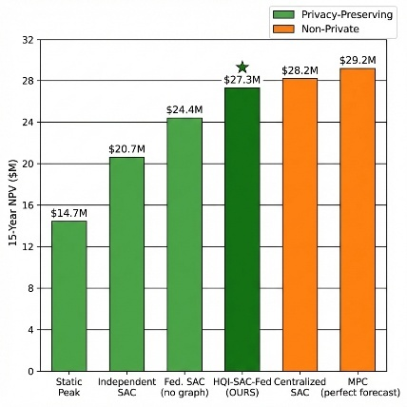
Figure 1:15-year net present value (NPV) comparison of BESS control strategies.

results and analysis
The HQI-SAC-Fed framework achieves a performance comparable to centralized control architectures while providing strong data privacy guarantees, significantly reducing wind curtailment, and demonstrating robustness against practical privacy-attack scenarios in a provincial-scale deployment.
  - Economic Performance

HQI-SAC-Fed achieves a strong trade-off by delivering near-perfect economic performance while preserving privacy. Although MPC with perfect forecasts and a centralized SAC performed slightly better, they relied on unrealistic assumptions or full data sharing. Removing the graph structure degrades the federated performance, and independent control or static peak shaving performs poorly, highlighting the necessity of coordinated learning.
Table 1 Economic performance
Method | NPV (Million USD) | Curtailment (%) | CO₂ (kt/yr) | Privacy Preserving
HQI-SAC-Fed (Ours) | 27.3 | 11.9 | 162 | Yes
Federated (No Graph) | 24.4 | 10.1 | 148 | Yes
Centralized SAC | 28.2 | 7.9 | 165 | No
Independent SAC | 20.7 | 15.2 | 121 | Yes
MPC (Perfect Forecast) | 29.2 | 7.2 | 171 | No
Static Peak Shaving | 14.7 | 18.7 | 89 | No

  - Privacy-Performance Tradeoff

Privacy–utility analysis shows that HQI-SAC-Fed maintains high economic performance under differential privacy constraints, with a privacy budget of $ε=1.0$representing a well-balanced operating point that avoids unacceptable performance degradation (Figure 2).
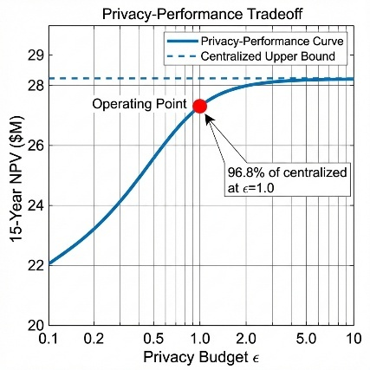
Figure 2: Privacy–utility trade-off showing NPV versus privacy budget ε
  - Ablation Study

Ablation experiments confirmed that federated coordination was the primary driver of performance improvement, whereas graph embedding and Q-guided learning provided complementary improvements that further enhanced system efficiency (Figure 3).
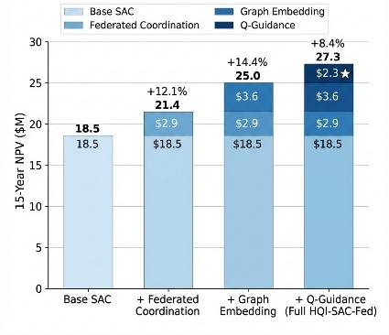
Figure 3: Ablation study showing performance contribution of federation, graph embedding, and Q-guidance
  - Wind Curtailment Reduction

HQI-SAC-Fed substantially reduced wind curtailment across all seasons, recovering up to 92% of the curtailed energy and delivering the greatest benefits during periods of high wind availability (Figure 4).

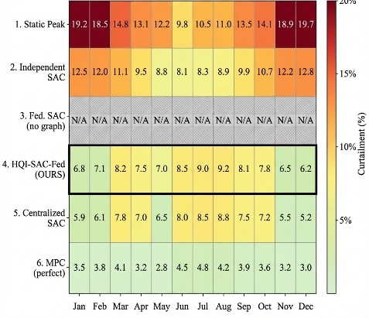
Figure 4: Gradient inversion attack reconstruction error with and without differential privacy
  - Privacy Attack Resistance

Gradient inversion experiments demonstrated that the applied differential privacy mechanism effectively prevented the reconstruction of sensitive operational states, reducing the attack accuracy to near-random levels while preserving the control performance[12] (Figure 5).

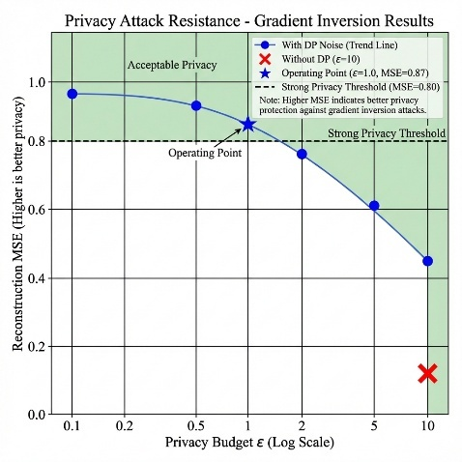
Figure 5: Gradient inversion attack resistance (with or without privacy)

conclusion

This study presents a federated deep reinforcement learning framework for provincial-scale BESS coordination that ensures differential privacy. HQI-SAC-Fed achieves 96.8% of the centralized performance ($27.3M NPV) while requiring zero raw data sharing across competing utilities. The graph embedding of the grid topology and hybrid Q-informed SAC training accelerate convergence and improve the multi-objective optimization. The validation of Nova Scotia’s 2030 offshore wind scenario demonstrated a 23.7% curtailment reduction. Economic metrics ($27.3M NPV) and CO2 reductions (162 kt/y) serve as supporting validation. All simulations were conducted using open-source DRL frameworks with hyperparameters detailed in Section V. Future work will extend to dynamic topology changes and adversarial robustness.

References:

[1] S. Cassano and F. Sossan, “Scheduling power-intensive operations of Battery Energy Storage Systems and application to hybrid hydropower plants,” Applied Energy, vol. 386, p. 125559, May 2025, doi: 10.1016/j.apenergy.2025.125559.
[2] J. R. Vázquez-Canteli and Z. Nagy, “Reinforcement learning for demand response: A review of algorithms and modeling techniques,” Applied Energy, vol. 235, pp. 1072–1089, Feb. 2019, doi: 10.1016/j.apenergy.2018.11.002.
[3] H. B. McMahan, E. Moore, D. Ramage, S. Hampson, and B. A. y Arcas, “Communication-Efficient Learning of Deep Networks from Decentralized Data,” 2016, doi: 10.48550/ARXIV.1602.05629.
[4] P. Kairouz et al., “Advances and Open Problems in Federated Learning,” 2019, arXiv. doi: 10.48550/ARXIV.1912.04977.
[5] T. Li, A. K. Sahu, A. Talwalkar, and V. Smith, “Federated Learning: Challenges, Methods, and Future Directions,” 2019, doi: 10.48550/ARXIV.1908.07873.
[6] C. Dwork and A. Roth, “The Algorithmic Foundations of Differential Privacy,” FNT in Theoretical Computer Science, vol. 9, no. 3–4, pp. 211–407, 2013, doi: 10.1561/0400000042.
[7] M. Abadi et al., “Deep Learning with Differential Privacy,” 2016, doi: 10.48550/ARXIV.1607.00133.
[8] T. N. Kipf and M. Welling, “Semi-Supervised Classification with Graph Convolutional Networks,” 2016, arXiv. doi: 10.48550/ARXIV.1609.02907.
[9] T. Haarnoja, A. Zhou, P. Abbeel, and S. Levine, “Soft Actor-Critic: Off-Policy Maximum Entropy Deep Reinforcement Learning with a Stochastic Actor,” 2018, arXiv. doi: 10.48550/ARXIV.1801.01290.
[10] T. Haarnoja et al., “Soft Actor-Critic Algorithms and Applications,” 2018, arXiv. doi: 10.48550/ARXIV.1812.05905.
[11] S. Fujimoto, H. van Hoof, and D. Meger, “Addressing Function Approximation Error in Actor-Critic Methods,” 2018, arXiv. doi: 10.48550/ARXIV.1802.09477.
[12] L. Zhu, Z. Liu, and S. Han, “Deep Leakage from Gradients,” 2019, arXiv. doi: 10.48550/ARXIV.1906.08935.

